Nginx Server Setup and Configuration on Ubuntu Server: -

1. Login Ubuntu Server root user
2. apt-get update
3. apt-get install nginx -y
4. ps aux | grep nginx (process show)

au = all user listing detailed information

x = include boot process

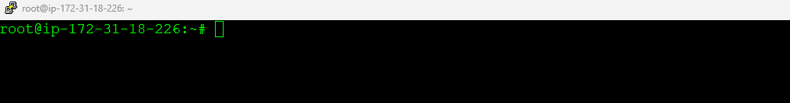

Building NGINX from source code and adding modules …

Go to <http://nginx.org/en/download.html> and right click on nginx-1.25.3 and copy link address

Go to ubuntu server and paste link

wget <http://nginx.org/download/nginx-1.25.3.tar.gz>



Extrat .tar.gz file

Go to extract directory.

./configure

apt-get install build-essential

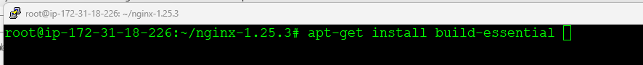

./configure

apt-get install libpcre3 libpcre3-dev zlib1g zlib1g-dev libssl-dev



./configure

Custom Configuration Nginx Server :-

Go to extract directory and run below command:-

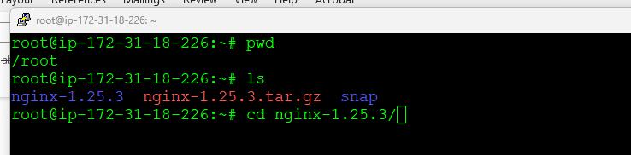

./configure --sbin-path=/usr/local/nginx/nginx --conf-path=/usr/local/nginx/nginx.conf --pid-path=/usr/local/nginx/nginx.pid --with-pcre --with-http_ssl_module --with-stream --with-http_auth_request_module

make

make install

ls /usr/local/nginx/

cd /usr/local/nginx/

rm -rf html

systemctl disable nginx

systemctl stop nginx

ls

nano ~/.bashrc

export PATH="/usr/local/nginx:$PATH"

vi /etc/profile

export PATH="/usr/local/nginx:$PATH"

Nginx stop and start and restart:-

nginx -s stop

nginx -s reload

Run nginx after reboot:-

sudo chmod +x /usr/local/nginx/nginx

sudo su -

chmod +x /usr/local/nginx/nginx

crontab -e

@reboot /usr/local/nginx/nginx -s stop; /usr/local/nginx/nginx

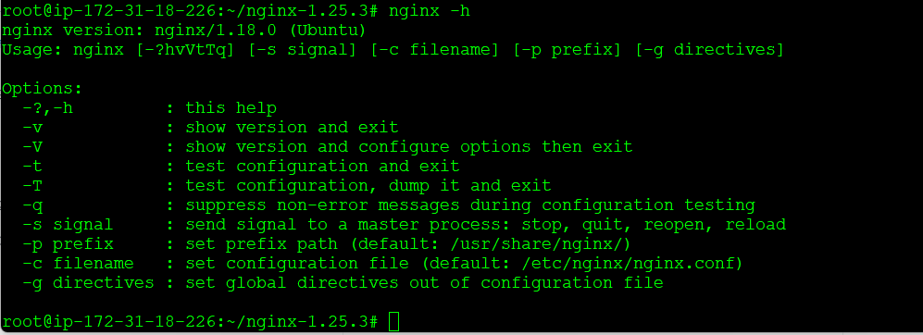

**Pm2 Installation :-**

sudo apt install curl

curl https://raw.githubusercontent.com/creationix/nvm/master/install.sh | bash

source ~/.bashrc

nvm install node

nvm install v18.12.0

node --version

nvm uninstall v19.0.0

nvm use v18.12.0

npm install pm2 -g

sudo apt update && apt install sudo curl && curl -sL https://raw.githubusercontent.com/Unitech/pm2/master/packager/setup.deb.sh | sudo -E bash -

pm2 ls

pm2 start pm2.config.js

pm2 startup

pm2 save

pm2 start pm2.config.js

pm2 save

pm2 startup

pm2 start pm2.config.js --update-env

pm2 delete all

Demo/qa/dev/alpha...

configure pm2

create folder root@ip-172-31-15-81:~# mkdir /code

root@ip-172-31-15-81:/code# mkdir config

create file root@ip-172-31-15-81:/code/config# vi pm2.config.js

access server via putty and enter below commands.

sudo su -

pm2 ps

pm2 stop user_service /id number

pm2 restart user_service /id number

Nginx system service create.

The location of the PIDFile and the NGINX binary may be different depending on how NGINX was compiled.

Save this file as /lib/systemd/system/nginx.service

**[Unit]**

Description=The NGINX HTTP and reverse proxy server

After=syslog.target network-online.target remote-fs.target nss-lookup.target

Wants=network-online.target

**[Service]**

Type=forking

PIDFile=/run/nginx.pid

ExecStartPre=/usr/sbin/nginx -t

ExecStart=/usr/sbin/nginx

ExecReload=/usr/sbin/nginx -s reload

ExecStop=/bin/kill -s QUIT $MAINPID

PrivateTmp=true

**[Install]**

WantedBy=multi-user.target

Create file



Edit file



